Exercise: Software List

* The following problem can be solved as either a Multi-Valued Attribute problem or a Repeated Attributes problem. Sometimes it takes more than just a glance at the class diagram to spot problems with a design.
* Consider the following class type that might be used by a software vendor to list software titles that are available.

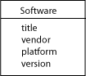

* There is nothing obviously wrong with this design. However, the users of this database might enter data that would cause problems, as shown in this table:

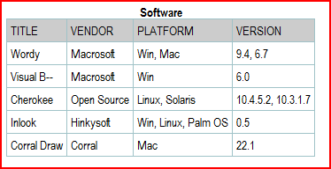

* + Revise the class diagram to correct any problems that you find in this design.
  + Then draw the relation scheme for your corrected model.